Lab: Git and GitHub
Problems for exercises and homework for the "Programming Fundamentals" course @ SoftUni.

Create a GitHub Developer Profile

Create a GitHub Profile
Register for a free developer account at GitHub: http://github.com. Submit your developer profile's URL as output of this homework.
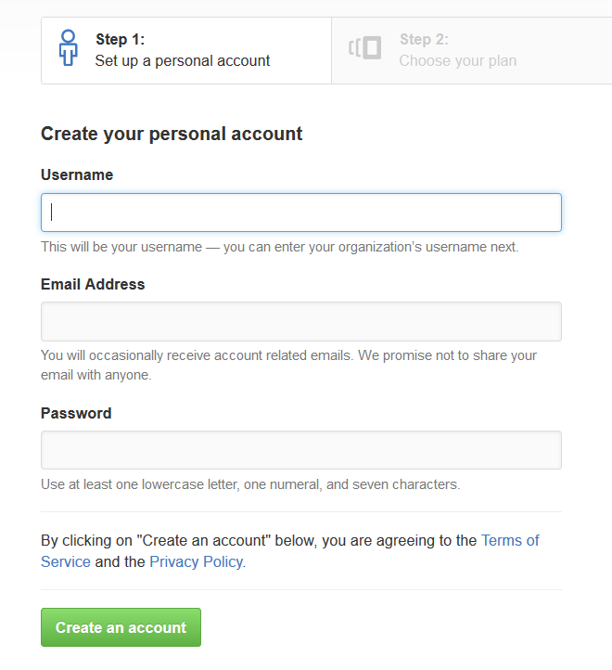

Creating a Repo + Conflict + Resolve

Create a GitHub Repository
- New repository form: https://github.com/new.
- Choose a name for the repo, e.g. "first-repo". Make sure to
"Initialize this repository with a README".
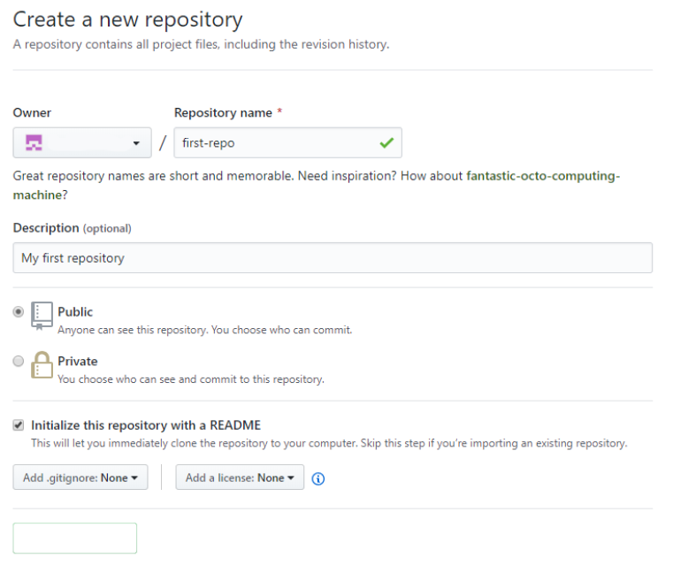

Clone a Repository Twice
Clone that repository on two different places on your personal device.
- Use Git clone for cloning with TortoiseGit.
- Go in the desired directory, right click on blank space anywhere in the folder and copy the link of your repository.
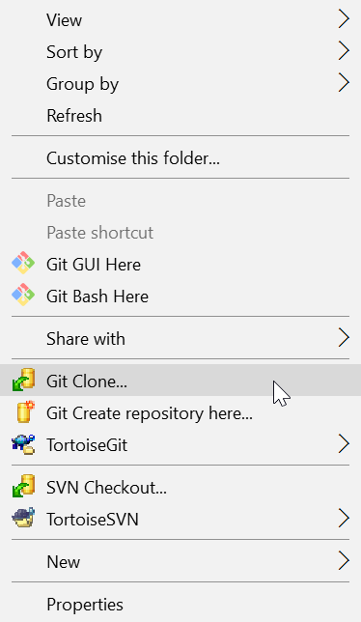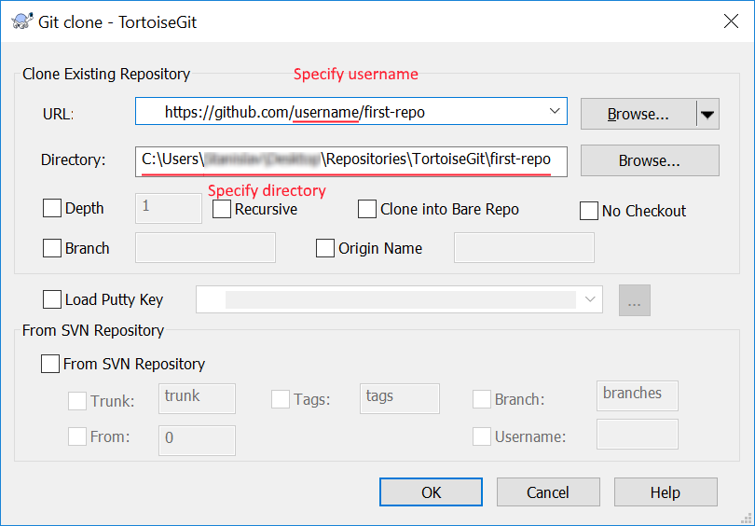
- The result should be something like this:
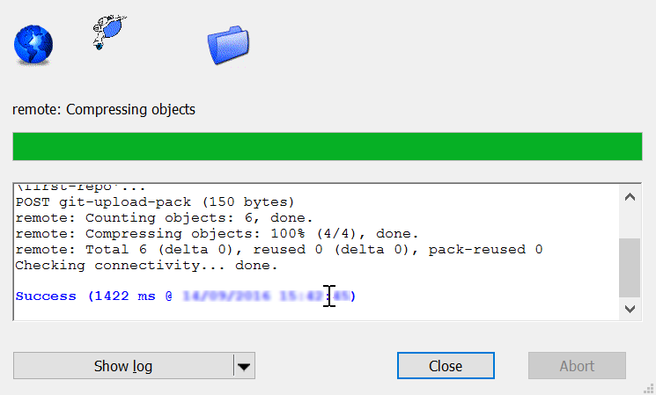
- Use "git clone" command for cloning with GitBash.
  - Go to the desired directory, right click on blank space anywhere in the folder, select "Git Bash here" and type "git clone" command followed by the link of your repository.
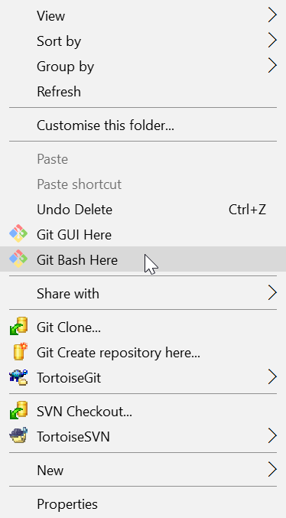
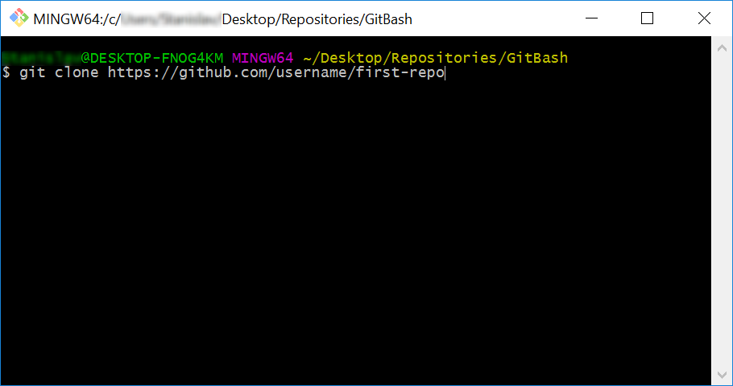
- The result should be something like this:
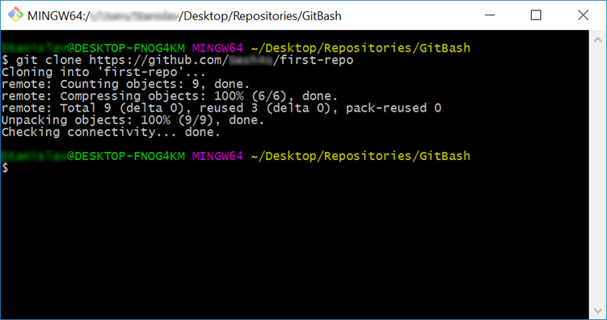

Make a Conflict
Update content in both directories differently:
- On your TortoiseGit clone create "test.txt" file and add line: "Creating with Tortoise…"
- On your GitBash clone create "test.txt" file and add line: "Creating with Bash…"

Upload Changes
Upload Your Changes from TortoiseGit Clone. You can use TortoiseGit's "Git Commit…":
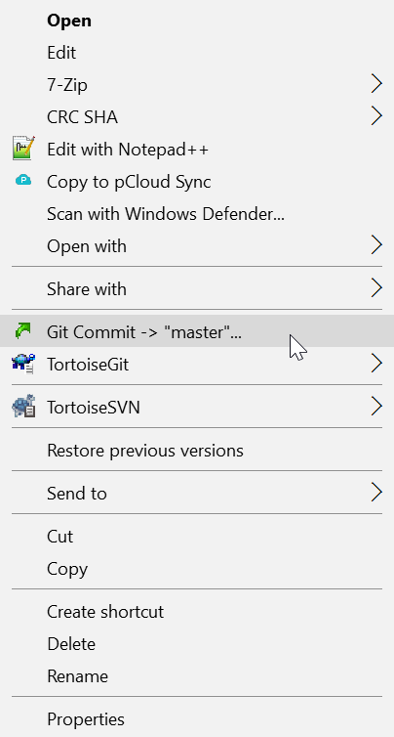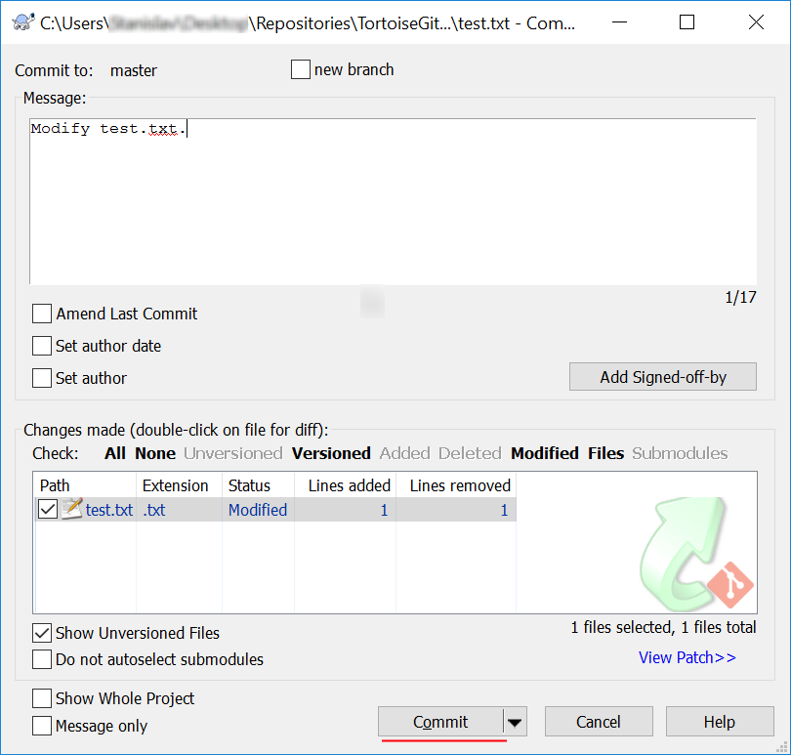
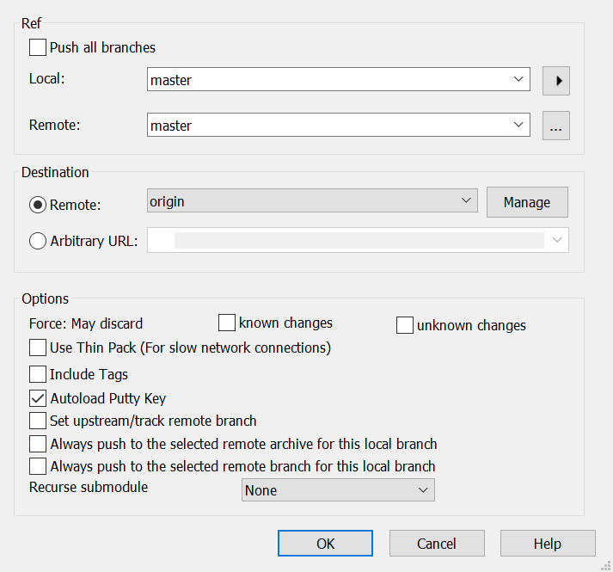
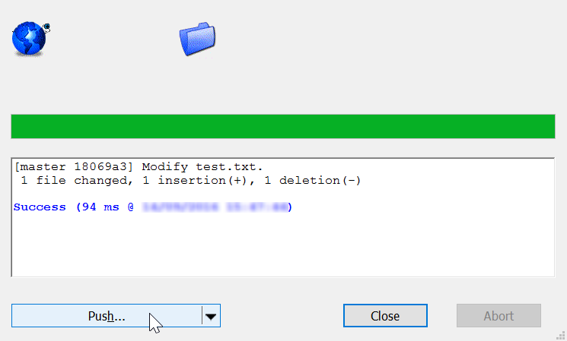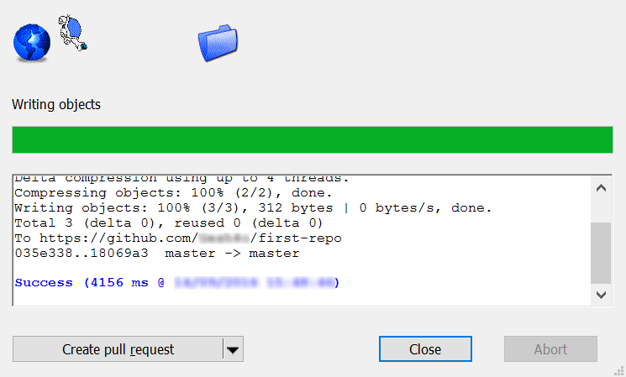

Update Bash Clone
- Open your Git clone directory and open GitBash console. Run the following commands:
  - Add all modified files to staging area
    - "git add ."
  - Commit your changes and a give commit message.
    - ''git commit -m "Update test.txt.""
  - Update your local repository
    - "git pull"
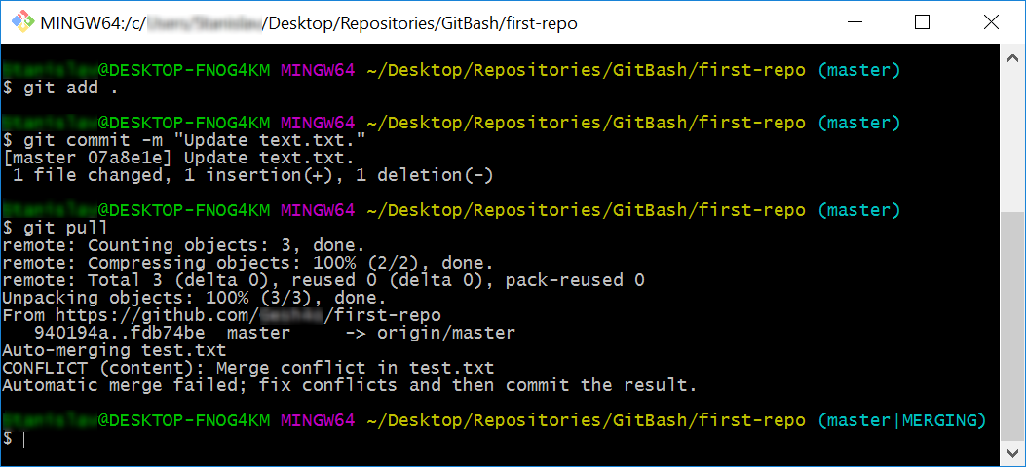

Merge Conflict
Now you have merge conflict which you have to resolve
  - Open the test.txt file in your GitBash clone, it should look like this:
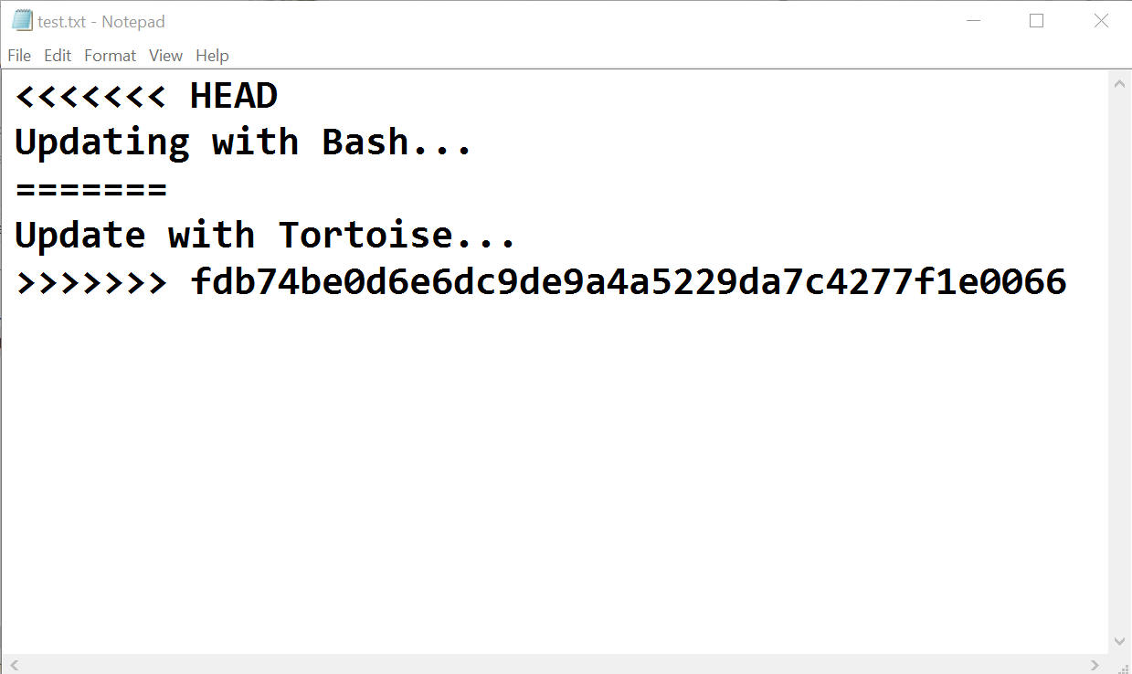

  - Remove the HEAD, ======, <<<<<<, >>>>>>> symbols and save the file.
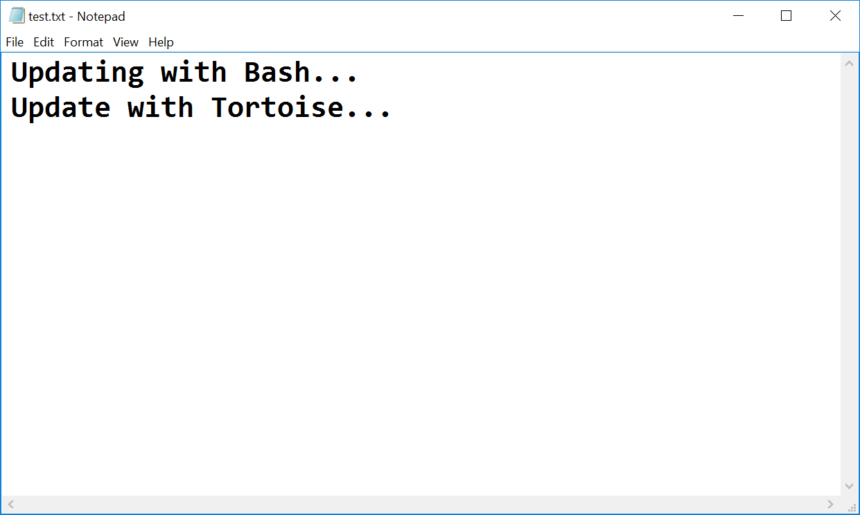
- Now that you have resolved the conflict - stage the modified file, commit again and
sync with the remote repository.
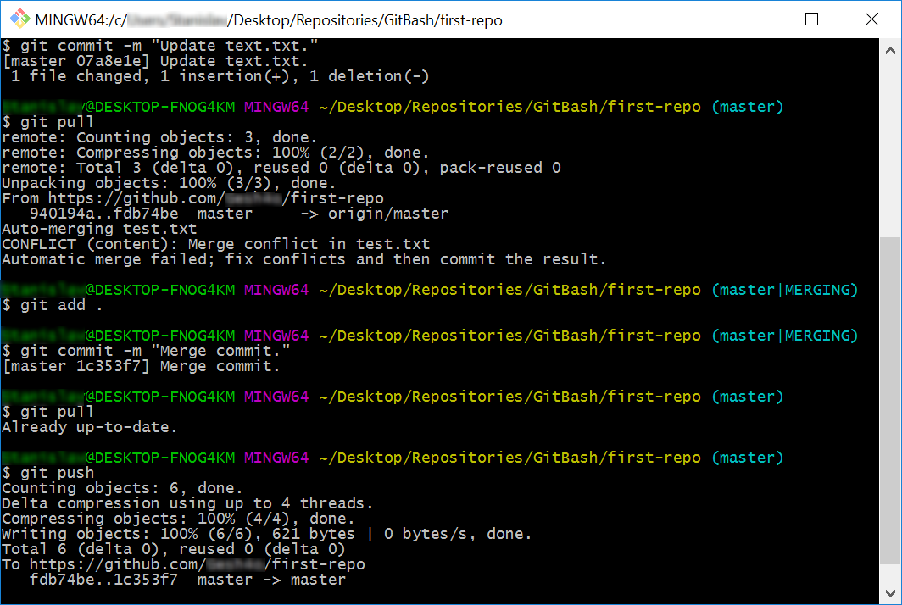

Merge Changes and Push to GitHub
You have updated the content of your remote repository, now try to update your TortoiseGit clone
- Make additional changes to test.txt and commit them.
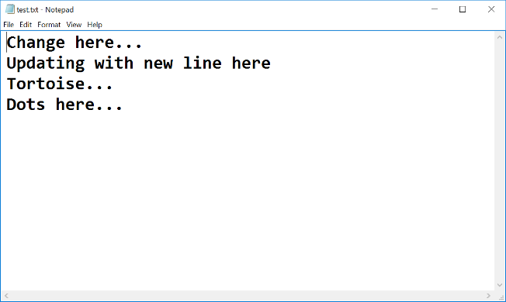
*Note that if you make changes too simple TortoiseGit may automatically merge them.
- Now try to push. It turns out that we have our remote repository updated (the merge commit) and we do not have these changes on our local repository.
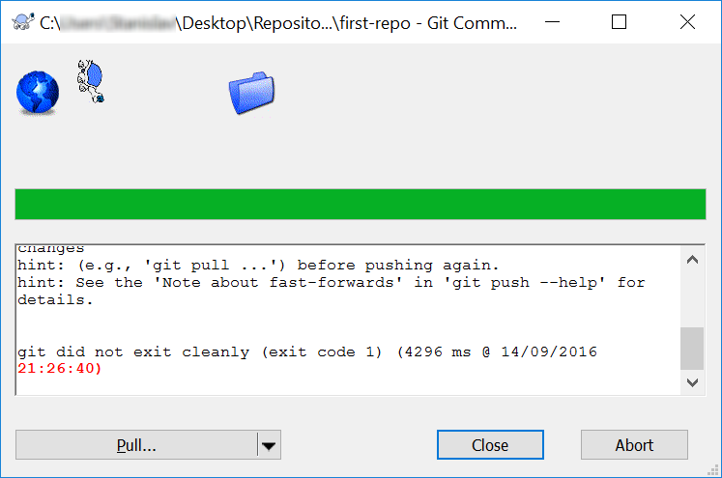
- So we have to pull new changes:
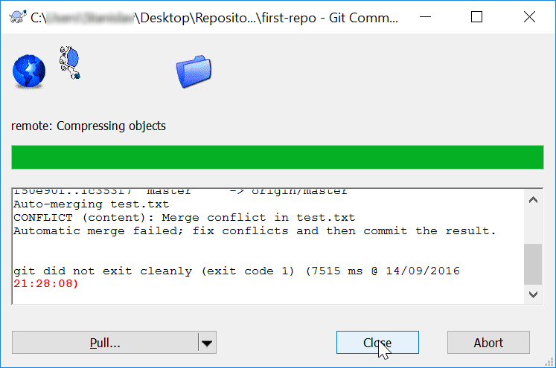
- Note that message: "Automatic merge failed; fix conflicts…". We have another conflict and we have to resolve it like we did earlier but small difference:
  - Go on the test.txt file. You should open the file and remove the same symbols that we have previously removed. Then right click on the file - choose TortoiseGit -> Resolve… and click it.
A dialog window should open. Then you click "Ok" in order to try to resolve the conflict.
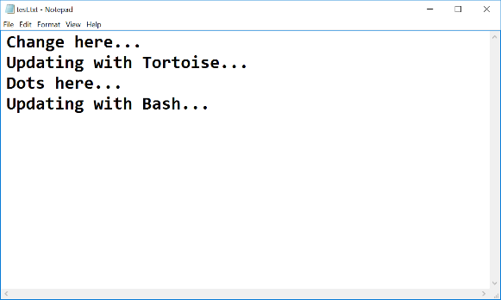
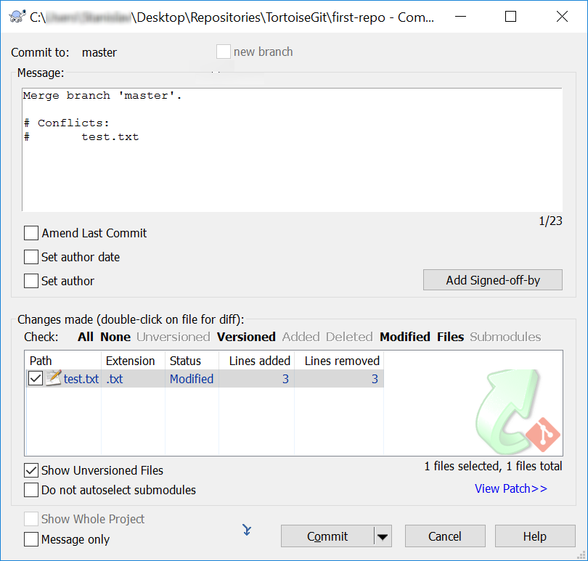
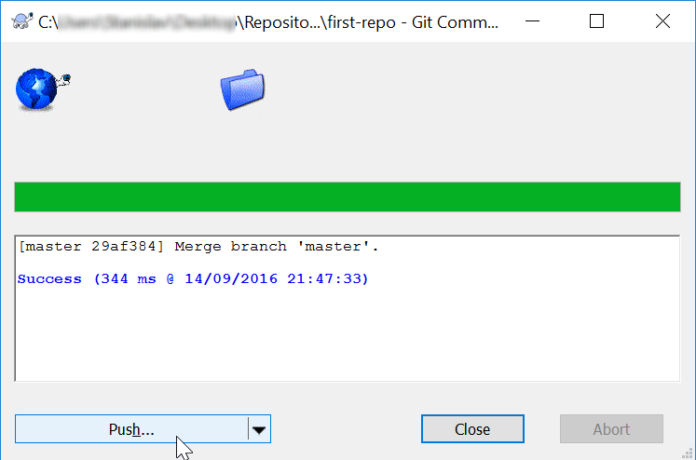
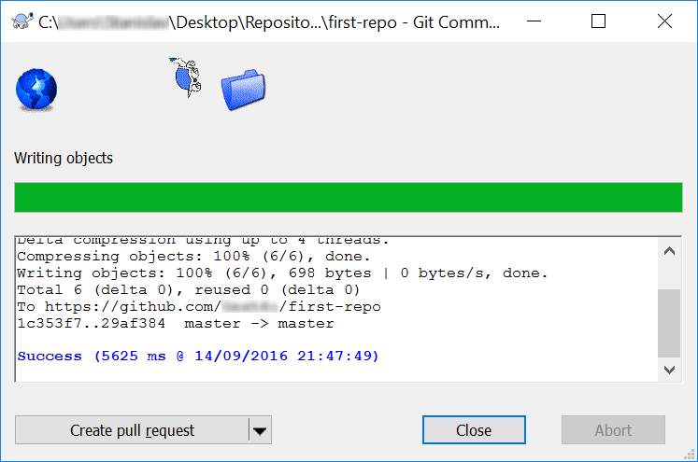
- Now our file is clean and we are ready for our final commit!

Meet Your Colleagues
It’s time to meet a couple of colleagues at SoftUni. For this exercise, you must submit a zip file with all the solutions from the problems below.

GitHub Profile Link
Create a new text document, called "1. GitHub Link.txt", and put a link to your GitHub profile inside it. The file should look something like this:
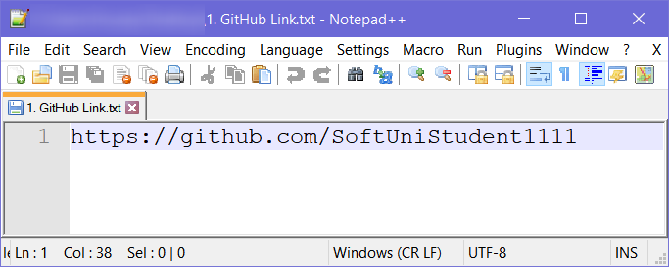

GitHub Repository Screenshot
Take a screenshot of your GitHub repository, using something like snipping tool, then save the file as
"2. GitHub Repo.jpg".

Meet Some Colleagues
First and foremost, look around the hall and try to make acquaintances with your fellow students. After you meet someone, note down the following information about them in a text document:
- What is their name?
- Where are they from?
- What hobbies/pastimes do they enjoy?
- Why did they pick SoftUni?
Try to do this with at least 3 students and also exchange contact information with them.
Hopefully you made a couple new friends from this exercise.

Upload Homework to SoftUni
Put all of the text files and screenshots you created in a zip file and send it as homework on the SoftUni site.

Teamwork
Work into teams of (about) 5 students in class
- Online students work alone or form own teams.
- Each team selects a "team leader".
The team leader creates a repository in GitHub e.g. "test-repo":

Add a File to GitHub
Team members add a few files:
- Clone the "test-repo" into your computer (if not cloned yet)
- Create a new file into your working directory
  - Name the new file "<your_name>.txt"
  - Put some text in it the file, e.g. "My name is …"
- Commit the new file to your local repository.
- Sync the changes to upload your file to the remote repo.
- Browse the repo from https://github.com/user/repo to check whether your file is successfully uploaded in GitHub.

Create a Git Conflict & Merge
- All team members create a common file "config.txt"
- Each team member adds some settings in "config.txt", e.g.:
  - name = Peter
  - size = 100
  - email = peter@dir.bg
- Each team member commits his local changes.
- Each team member syncs his changes.
  - The first member will succeed without conflicts.
  - The others will have a conflict to be merged.
  - Resolve the conflict:
    - Edit the merged changes + commit and sync again.

